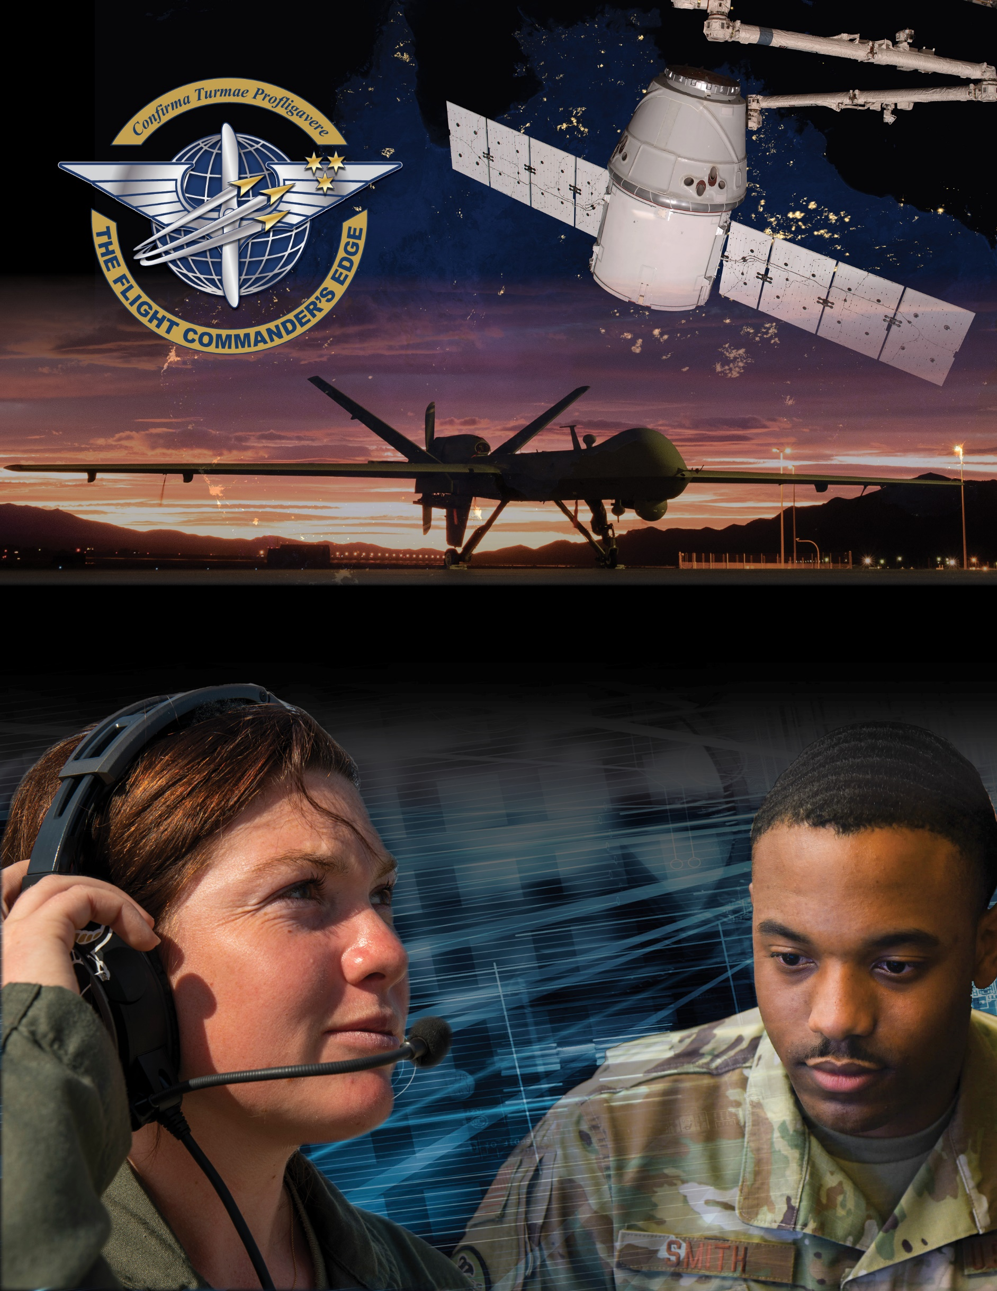

**Lesson Guide**



**Networking**

***14 April 2025***

**Networking**

### Purpose

This lesson guide is designed to support the local development of Flight Commander Leadership Course materials. Selected facilitators should use this guide as they prepare presentation materials. For more information on how lessons are structured, or how to use them in the course, see the ***Course Director’s Handbook*** or online Facilitator Resources.

### Scope

Networking plays a vital role in gaining perspective and experience at all levels. Through networking, you can leverage the experiences of others to optimize your approach to various situations. Networking can also be a way to make contacts in other units, providing informal channels for advice and information.

As a Flight Commander you will be involved with disciplinary issues, organizational dilemmas, and a myriad of other matters which inevitably arise in organizations. Networking can help offer a fresh perspective on situations within your unit or can be an avenue to seek mentorship or advice. With the advancement of technology, avenues of networking now include both the physical (Air Force or Space Force professional organizations or clubs, CGOC, etc.) and the electronic (social media sites). Networking that shares knowledge, experience, and information benefits all Airmen and Guardians.

### Recommended Objectives

By the end of this lesson, the participant should be able to:

1. Recognize the benefits of networking with other leaders and peers.
2. Discuss ways to benefit from the experiences and perspectives of others.
3. Discuss methods of enhancing your networking environment.

### Recommended POC / Presenter

* Accomplished networker (Squadron DO, Flt/CC, SNCO, or equivalent)

### Recommended Length:

* 25 minutes (inclusive of questions)

### Recommended Approach

* Present informational slides with Q & A

### Lesson Connections

* **Emotional Intelligence-**since any network is composed of individuals, understanding emotional intelligence will help optimize networking skills and efforts.
* **Leading Change-**Change with organizational impact can be challenging for leaders. A network can offer valuable advice and perspective for leading amidst or implementing change.
* **Discipline, NJP, and the UCMJ-**as a Flight Commander you will be involved with disciplinary issues, organizational dilemmas, legal situations, and a myriad of other matters which inevitably arise. Networking can help offer a fresh perspective on such situations.
* **Mentoring-**networking can be an avenue to seek mentorship or advice.